Craig Pulford

Test Cases Module 4

Project code: https://github.com/craigPulfEdu/CMPS162/blob/master/Module_4/module-4-programming-project.html

Part 1 (greet)

Part 2 (make two numbers add together with a function )

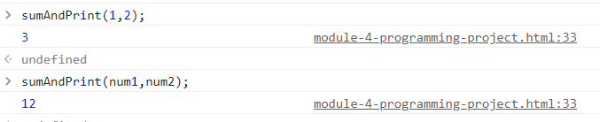

Part 3 (sum of elements and make undefined input/no input values zero)

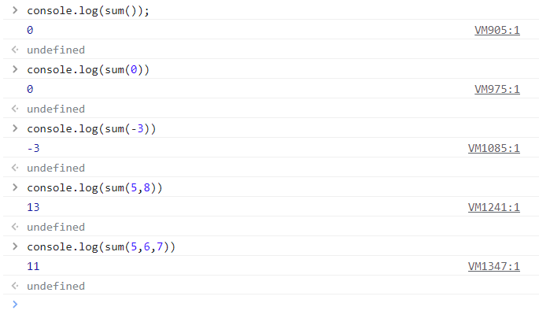

Part 4 (find smallest element in an array)





Part 5 (function “everySecondElement” that finds every second element in an array)

Part 1 (Switch convert month integer to string)

Part 1 (Factortial While function)

Part 2 (Factorial do While)





Factorial For (used to make the two functions above this)

